1. **Software Design / Diagrams** 
   1. **Requirements Analysis** 
      1. **User Scenarios** 
         1. **User Scenarios List**

|  |  |  |
| --- | --- | --- |
| Nr. | Name | Description |
| US_01 | User logs in | Users: Classified into normal users, agents and the admin. |
| US_02 | Change Username | Users: All the users of the three levels of access can change their username. |
| US_03 | Change Password | Users: All the users of the three levels of access can change their password. |
| US_04 | Change email | Users: All the users can change their email after being logged in to their account |
| US_05 | Change status | Admin: The admin can change the status of the user by upgrading them to an agent or admin |
| US_06 | Change address | Users: All the users can change their address if any possible changes have happened |
| US_07 | View Properties’ List | The agent and admin can view all properties. |
| US_08 | Make an enquiry | The registered user can make an enquiry for an agent. |
| US_09 | Search Agent | The registered users can search for agents. |
| US_10 | Search Property | Registered users, agents and admin can search for properties. |

|  |  |  |
| --- | --- | --- |
| US_11 | Agent Logs in | The same process as a normal user would log in. |
| US_12 | Add Property | An action accessible only by agents and the admin. |
| US_13 | View Property List | An action accessible only by agents and the admin. |
| US_14 | Create an auction/open house event | The agent can create auction events and open house events. |
| US_15 | Update Property Information | Property information can be updated by agents and the admin. |
| US_16 | Post a new property | The agent or a client can post a new property and list it as for sale or for rent |
| US_17 | Sell a property | The agent can sell a property |
| US_18 | Administrator logs in | The same process as a normal user would log in. |
| US_19 | View Agent List | An action accessible to the normal registered user and the administrator. |
| US_20 | View Agent Profile | This action is available only for registered users and the admin. |
| US_21 | View Statistics | The agent and the admin can view the statistics. |
| US_22 | User Logs out (for all three levels of access) | Valid for the three levels of access. (log out in the same way) |
| US_23 | Rent a property | The agent can rent a property to a client and remove it from the property listings |
| US_24 | Answer the live chat | The available agent can answer to the questions done through the live chat option |
| US_25 | Search by location | The user can search for a property based on location |
| US_26 | Search by building area | The client can search for a property based on building area |
| US_27 | Search by agent ID | The client can search for a property based on the agent id associated with each agent |
| US_28 | Delete user | A feature available only to the admin privileges where the admin can delete a user |
| US_29 | Add user | Admin can create a new user and set its status |
| US_30 | Edit user data | Admin can edit the user data if any mistake was made |
| US_31 | Delete property | The admin and agent are able to delete the property from the listing |
| US_32 | Edit property | The admin can change the data of a property |
| US_33 | Sign up | A new user can sign up by entering the required data and creating an account as a client |

**4.1.1.2 User Scenarios Extended**

**User Scenario 1:**

* **Name:** User logs in
* **Extended Description:**
  + User chooses his entry : user/agent/admin
  + User is redirected to the login page
  + User enters his username and password
  + User checks the reCaptcha ‘I am not a robot’
  + User presses the login button
  + If data is correct the user's profile is displayed
  + If data is not correct a message will be shown in the screen and user repeats the process from step b.(sent back to the login page)

**User Scenario 2:**

* **Name:** Change Username
* **Extended Description:**
  + User logs in following the steps in US_01.
  + User chooses the menu “Change Username”
  + User types his password to confirm “identity”
  + User presses the button “Save Changes” after putting the new username
  + If the password is correct and username meets criteria the user is notified via a message "Changes saved"
  + In case the password is wrong or username does not meet criteria the user is shown error message "Username not changed check criteria or password"

**User Scenario 3:**

* **Name:** Change password
* **Extended Description:**
  + User logs in following the steps in US_01.
  + User chooses the menu “Change Password”
  + User types his old password and his new password (2 times)
  + User presses the button “Save Changes”
  + If the old password is correct and if the new password is the same in both fields and meets criteria the user is alerted: “Password was changed successfully!”
  + In case the old password is wrong or the new password is not the same in both fields or does not

meet criteria then the user is alerted: “Password was not changed. Please try again.”

**User Scenario 4:**

* **Name:** Change email
* **Extended Description:**
  + User logs in following the steps in US_01.
  + User chooses the menu “Change email”
  + User types his old email and his new desired email and his password for confirming his "identity" (2 times)
  + User presses the button “Save Changes”
  + If the password is correct an confirming email is sent to the new email. When confirmed user is alerted "Email changed"
  + If password is not correct then user is shown an error message "password not correct"

**User Scenario 5:**

* **Name:** Change status
* **Extended Description:**
  + Admin logs in following the steps in US_01.
  + Admin chooses the menu “Change status”
  + Admin types his password to confirm his identity

Admin enters the username of user or agent which wants to change status and upgrades its status to user agent or admin.

* + If username corresponds to a username in database its status is changed and a message is shown "status changed successfully"
  + If username does not correspond to a username in database then an error message is shown "Status not changed.User not found"

**User Scenario 6:**

* **Name:** Change address
* **Extended Description:**
  + User logs in following the steps in US_01.
  + User chooses the menu “Change Address”
  + User types his password to confirm identity and enters the new address
  + User presses the button “Save Changes”
  + If the password is correct the user is alerted: “Address was changed successfully!”
  + In case the password is wrong then the user is alerted: “Address was not changed. Please try

again.”

**User Scenario 7:**

* **Name:** View property´s list
* **Extended Description:**
  + Admin/Agent logs in following the steps in US_01.
  + Admin/Agent chooses the menu “View property´s list”
  + Admin/Agent types his password to confirm identity ● A list of all properties is shown with their respective details.

**User Scenario 8:**

* **Name:** Make an enquiry
* **Extended Description:**
  + User logs in following the steps in US_01.
  + User uses the tab make an enquiry in the front page
  + Users can make an inquiry about an agent or property.

**User Scenario 9:**

* **Name:** Search Agent
* **Extended Description:**

User logs in following the steps in US_01.

* + User chooses the menu “Search Agent”
  + User types the username of the agent
  + User presses the button “Search”
  + If the username exists the agent´s profile appears
  + If the username does not exist an error message is shown to the user "Agent not found. Try again"

**User Scenario 10:**

* **Name:** Search Property
* **Extended Description:**
  + User logs in following the steps in US_01.
  + User chooses the menu “Search Property”
  + User types the property's unique "number"
  + User presses the button “Search”
  + If the "number" exists the property appears together with its details
  + If the number does not exist an error message is shown to the user "Property not found. Try again"

**User Scenario 11:**

* **Name:** Agent logs in
* **Extended Description:**
  + User chooses his entry as agent
  + User is redirected to the login page
  + User enters his username and password
  + User checks the reCaptcha ‘I am not a robot’
  + User presses the login button
  + If data is correct the agent´s profile is displayed
  + If data is not correct a message will be shown in the screen and user repeats the
  + process from step b.(sent back to the login page)

**User Scenario 12:**

* **Name:** Add Property
* **Extended Description:**
  + The admin or agent logs into the real estate website using their unique credentials.
  + Once logged in, they navigate to the "Property Management" or "Listings" section.
  + In this section, they click on the "Add Property" or "Create Listing" button to open the new property creation form.
  + They fill in the required fields for the new property, such as address, property type, price, description, and photos.
  + They may also be asked to provide additional information, such as the number of bedrooms, bathrooms, building area, and any unique features or amenities.
  + After completing the form, they click on the "Save" or "Create" button to submit the new property data.
  + The website processes the request and creates a new property listing with the specified information.
  + The admin or agent receives a notification or confirmation message that the new property listing has been successfully created.

**User Scenario 13:**

* **Name: View Property List**
* **Extended Description:**
  + The admin or agent logs into the real estate website using their unique credentials.
  + Once logged in, they navigate to the "Property Management" or "Listings" section.
  + In this section, they can view a list of all properties, including relevant details such as address, price, property type, status, and agent information.
  + They can also filter or sort the property list based on various criteria, such as location, price range, date added, or property type.
  + By clicking on individual property listings, they can access more detailed information, edit the property data, or delete the listing.

**User Scenario 14:**

* **Name: Create an auction/open house event**
* **Extended Description:**
  + The agent logs into the real estate website using their unique credentials.
  + Once logged in, they navigate to a dedicated "Events" or "Open Houses & Auctions" section.
  + In this section, they click on the "Create Event" or "Schedule Open House/Auction" button to open the new event creation form.
  + They fill in the required fields for the new event, such as the event type (auction or open house), associated property, date, time, and any additional information or instructions for attendees.
  + They may also be asked to provide the event's location, which could be the property address or a different venue.
  + After completing the form, they click on the "Save" or "Create" button to submit the new event data.
  + The website processes the request and creates a new auction or open house event with the specified information.
  + The agent receives a notification or confirmation message that the new event has been successfully created and can now be promoted to potential attendees.

**User Scenario 15:**

* **Name: Update Property Information**
* **Extended Description:**
  + The admin or agent logs into the real estate website using their unique credentials.
  + Once logged in, they navigate to the "Property Management" or "Listings" section.
  + In this section, they can view a list of all properties and their relevant details.
  + They identify the property whose information they want to update by searching for specific criteria, such as the address or property ID.
  + After locating the desired property, they click on the "Edit" or "Modify" button associated with the property listing.
  + An edit form appears, displaying the property's current information and allowing the admin or agent to make changes to any editable fields, such as price, description, photos, or status.
  + They make the necessary changes to the property information and click on the "Save" or "Update" button to submit the updated information.
  + The website processes the request and updates the property listing with the modified data.
  + The admin or agent receives a notification or confirmation message that the property information has been successfully updated.

**User Scenario 16:**

* **Name: Post a new property**
* **Extended Description:**
  + The agent or client logs into the real estate website using their unique credentials.
  + Once logged in, they navigate to the "Post a Property" or "Add Listing" section.
  + In this section, they click on the "Add Property" or "Create Listing" button to open the new property submission form.
  + They fill in the required fields for the new property, such as address, property type, price, description, and photos.
  + They may also be asked to provide additional information, such as the number of bedrooms, bathrooms, building area, and any unique features or amenities.
  + They specify whether the property is for sale or for rent by selecting the appropriate option.
  + After completing the form, they click on the "Submit" or "Create" button to submit the new property data.
  + The website processes the request and creates a new property listing with the specified information, pending approval by an admin or agent.
  + The agent or client receives a notification or confirmation message that the new property listing has been successfully submitted and is awaiting approval.

**User Scenario 17:**

* **Name: Sell a property**
* **Extended Description:**
  + The agent logs into the real estate website using their unique credentials.
  + Once logged in, they navigate to the "Property Management" or "Listings" section.
  + In this section, they can view a list of all properties and their relevant details.
  + They identify the property they want to mark as sold by searching for specific criteria, such as the address or property ID.
  + After locating the desired property, they click on the "Edit" or "Modify" button associated with the property listing.
  + An edit form appears, displaying the property's current information and allowing the agent to change the property's status to "Sold" or a similar designation.
  + They update the property status and click on the "Save" or "Update" button to submit the updated information.
  + The website processes the request and updates the property listing with the new status, removing it from the active listings.
  + The agent receives a notification or confirmation message that the property has been successfully marked as sold.

**User Scenario 18:**

* **Name:** Administrator logs in
* **Extended Description:**
  + The administrator visits the real estate website and navigates to the "Login" or "Sign In" page.
  + They enter their unique email address or username and password associated with their admin account in the provided fields.
  + They click on the "Login" or "Sign In" button to submit their credentials.
  + The website processes the request, verifies their admin status, and grants them access to the admin panel or dashboard.
  + Once logged in, the administrator can manage various aspects of the website, such as users, property listings, events, and other administrative tasks.

**User Scenario 19:**

* **Name: View Agent List**
* **Extended Description:**
  + The registered user or administrator logs into the real estate website using their unique credentials. ● Once logged in, they navigate to the "Agent List" or "Our Agents" section.
  + In this section, they can view a list of all agents, including relevant details such as agent name, photo, contact information, and a short bio.
  + They can also filter or sort the agent list based on various criteria, such as location, specialization, or experience.
  + By clicking on individual agent names or photos, they can access more detailed information about the agent, including their profile and any associated property listings.

**User Scenario 20:**

* **Name:** View Agent Profile
* **Extended Description:**
  + The registered user or administrator logs into the real estate website using their unique credentials. ● Once logged in, they navigate to the "Agent List" or "Our Agents" section.
  + In this section, they identify the agent whose profile they want to view by searching for specific criteria, such as name or location.
  + After locating the desired agent, they click on the agent's name or photo to access the agent's profile page.
  + The agent's profile page displays more detailed information, such as the agent's full bio, contact information, social media links, customer reviews, and a list of associated property listings.
  + The registered user or admin can use this information to learn more about the agent's expertise, experience, and available properties, helping them decide whether to work with the agent for their real estate needs.

**User Scenario 21:**

* **Name:** View Statistics
* **Extended Description:**
  + The agent or administrator logs into the real estate website using their unique credentials.
  + Once logged in, they navigate to the "Statistics" or "Analytics" section.
  + In this section, they can view various data and insights related to the website's performance, property listings, and user interactions.
  + The statistics may include information such as the number of active property listings, the number of properties sold or rented, total revenue generated, website traffic and user behavior, and other key performance indicators.
  + The agent or admin can filter or customize the statistics based on specific timeframes or other criteria to gain a better understanding of trends, performance, and areas for improvement.
  + These insights can help the agent or admin make data-driven decisions to enhance the website's functionality, improve property listings, and better serve clients.

**User Scenario 22:**

* **Name:** User Logs out (for all three levels of access)
* **Extended Description:**
  + The user (client, agent, or administrator) navigates to the "Logout" or "Sign Out" button or option, which is typically located in the top-right corner of the screen or in a dropdown menu under the user's profile.
  + The user clicks on the "Logout" or "Sign Out" button or option to initiate the logout process.
  + The website processes the request, logs the user out of their account, and returns them to the public-facing home page or login screen.
  + As a result, the user's session ends, and they can no longer access any restricted or personalized content on the website.
  + To regain access to restricted or personalized content, the user must log in again using their unique credentials.

**User Scenario 23:**

* **Name:** Rent a property
* **Extended Description:**
  + The client browses the website's property listings and identifies a property they are interested in renting.
  + The client clicks on the "Rent" or "Inquire" button associated with the property, which directs them to a contact form.
  + The client fills in their contact information and any additional comments or questions regarding the rental process and submits the form.
  + The real estate agent receives the client's inquiry and contacts the client to discuss the rental process, property availability, and any other relevant details.
  + The agent and client reach an agreement on the rental terms, and the client provides the necessary documentation and payment.
  + The agent finalizes the rental agreement and provides the client with a copy of the contract and any other necessary documents.
  + Once the rental process is completed, the agent logs into the website's backend system and updates the property status to "Rented" or "Unavailable."
  + The property is automatically removed from the public listings on the website, and potential clients can no longer inquire about it.

**User Scenario 24:**

* **Name:** Answer the live chat
* **Extended Description:**
  + A potential client or existing customer visits the real estate website and has questions or needs assistance.
  + The user notices a "Live Chat" button or widget on the website and clicks on it to initiate a conversation.
  + A chat window opens, and the user types their question or request in the message input field.
  + The website's system automatically sends a notification to all available agents, informing them of the new live chat request.
  + The first available agent clicks on the notification and is taken to the chat interface where they can view the user's question or request.
  + The agent types a response to the user's message and sends it through the chat interface.
  + The user receives the agent's response in the chat window and can continue the conversation by typing and sending additional messages.
  + The agent and user engage in a conversation, with the agent providing assistance, answering questions, and addressing any concerns the user might have.
  + Once the user's questions or concerns are resolved, the agent politely ends the conversation by asking if there's anything else they can help with and wishing the user a great day.
  + The live chat session is closed, and both the user and agent can return to their respective tasks.

**User Scenario 25:**

* **Name:** Search by location
* **Extended Description:**
  + A user visits the real estate website, looking for properties in a specific location.
  + The user navigates to the "Property Search" page or uses a search bar prominently displayed on the homepage.
  + On the "Property Search" page, the user is presented with various search filters, including a "Location" filter.
  + The user can search by location in multiple ways: a. By entering a city, neighborhood, or street name into a search box b. By selecting a predefined area from a dropdown menu or list c. By using an interactive map, where they can zoom in, pan, or draw a search area
  + After specifying their desired location, the user can optionally apply additional filters such as property type, price range, number of bedrooms, etc., to further refine their search.
  + The user clicks on the "Search" or "Apply Filters" button to initiate the search.
  + The website processes the search query and displays a list of properties that match the user's selected location and other specified criteria.
  + Each property listing includes relevant information such as photos, descriptions, prices, and contact details for the real estate agent.
  + The user can click on individual property listings to view more details, save them for later, or contact the agent to inquire about the property

.

**User Scenario 26:**

* **Name:** Search by building area
* **Extended Description:**
  + A client visits the real estate website, interested in finding properties that meet their desired building area requirements.
  + The client navigates to the "Property Search" page or uses a search bar prominently displayed on the homepage.
  + On the "Property Search" page, the client is presented with various search filters, including a "Building Area" filter.
  + The client can input their preferred minimum and maximum building area (usually in square feet or square meters) in the appropriate fields or use a slider to define the desired range.
  + After specifying their desired building area, the client can optionally apply additional filters such as location, property type, price range, number of bedrooms, etc., to further refine their search.
  + The client clicks on the "Search" or "Apply Filters" button to initiate the search.
  + The website processes the search query and displays a list of properties that match the client's selected building area range and other specified criteria.
  + Each property listing includes relevant information such as photos, descriptions, prices, and contact details for the real estate agent.
  + The client can click on individual property listings to view more details, save them for later, or contact the agent to inquire about the property.

**User Scenario 27:**

* **Name:** Search by agent ID
* **Extended Description:**
  + A client visits the real estate website, looking for properties managed by a specific agent, knowing their agent ID.
  + The client navigates to the "Property Search" page or uses a search bar prominently displayed on the homepage.
  + On the "Property Search" page, the client is presented with various search filters, including an "Agent ID" filter.
  + The client enters the agent ID in the appropriate field or selects it from a list of available agents.
  + After specifying the agent ID, the client can optionally apply additional filters such as location, property type, price range, number of bedrooms, etc., to further refine their search.
  + The client clicks on the "Search" or "Apply Filters" button to initiate the search.
  + The website processes the search query and displays a list of properties associated with the specified agent ID and other specified criteria.
  + Each property listing includes relevant information such as photos, descriptions, prices, and contact details for the real estate agent.
  + The client can click on individual property listings to view more details, save them for later, or contact the agent to inquire about the property.

**User Scenario 28:**

* **Name:** Delete user
* **Extended Description:**
  + The admin logs into the real estate website's admin panel using their unique credentials.
  + Once logged in, the admin navigates to the "User Management" or "Accounts" section.
  + In this section, the admin can view a list of all registered users, including their names, contact information, roles, and other relevant details.
  + The admin identifies the user they want to delete by searching for their name, email, or any other identifying information.
  + After locating the desired user, the admin clicks on the "Delete" or "Remove" button associated with the user's account.
  + A confirmation prompt appears, asking the admin to verify their intention to delete the user account.
  + The admin confirms their decision by clicking on the "Yes" or "Confirm" button in the prompt.
  + The website processes the request and permanently deletes the user account and all associated data.
  + The admin receives a notification or confirmation message that the user account has been successfully deleted.

**User Scenario 29:**

* **Name:** Add user
* **Extended Description:**
  + The admin logs into the real estate website's admin panel using their unique credentials.
  + Once logged in, the admin navigates to the "User Management" or "Accounts" section.
  + In this section, the admin clicks on the "Add User" or "Create User" button to open the new user creation form.
  + The admin fills in the required fields for the new user, such as name, email, password, contact information, and user role (e.g., agent, client, or admin).
  + The admin can also set the user's status, such as "Active" or "Inactive," to determine if the user can access the website and perform actions according to their assigned role.
  + After completing the form, the admin clicks on the "Save" or "Create" button to submit the new user data.
  + The website processes the request and creates a new user account with the specified information and settings.
  + The admin receives a notification or confirmation message that the new user account has been successfully created.

**User Scenario 30:**

* **Name:** Edit user data
* **Extended Description:**
  + The admin logs into the real estate website's admin panel using their unique credentials.
  + Once logged in, the admin navigates to the "User Management" or "Accounts" section.
  + In this section, the admin can view a list of all registered users, including their names, contact information, roles, and other relevant details.
  + The admin identifies the user whose data they want to edit by searching for their name, email, or any other identifying information.
  + After locating the desired user, the admin clicks on the "Edit" or "Modify" button associated with the user's account.
  + An edit form appears, displaying the user's current data and allowing the admin to make changes to any editable fields, such as name, email, contact information, role, or status.
  + The admin makes the necessary changes to the user data and clicks on the "Save" or "Update" button to submit the updated information.
  + The website processes the request and updates the user account with the modified data.
  + The admin receives a notification or confirmation message that the user data has been successfully updated.

**User Scenario 31:**

* **Name:** Delete property
* **Extended Description:**
  + The admin or agent logs into the real estate website using their unique credentials.
  + Once logged in, they navigate to the "Property Management" or "Listings" section.
  + In this section, they can view a list of all properties, including relevant details such as address, price, property type, and status.
  + They identify the property they want to delete by searching for specific criteria, such as the address or property ID.
  + After locating the desired property, they click on the "Delete" or "Remove" button associated with the property listing.
  + A confirmation prompt appears, asking them to verify their intention to delete the property listing. ● They confirm their decision by clicking on the "Yes" or "Confirm" button in the prompt.
  + The website processes the request and permanently deletes the property listing and all associated data.
  + They receive a notification or confirmation message that the property listing has been successfully deleted.

**User Scenario 32:**

* **Name:** Edit property
* **Extended Description:**
  + The admin logs into the real estate website's admin panel using their unique credentials.
  + Once logged in, they navigate to the "Property Management" or "Listings" section.
  + In this section, they can view a list of all properties and their relevant details.
  + They identify the property whose data they want to edit by searching for specific criteria, such as the address or property ID.
  + After locating the desired property, they click on the "Edit" or "Modify" button associated with the property listing.
  + An edit form appears, displaying the property's current data and allowing the admin to make changes to any editable fields, such as price, description, photos, or status.
  + The admin makes the necessary changes to the property data and clicks on the "Save" or "Update" button to submit the updated information.
  + The website processes the request and updates the property listing with the modified data.
  + The admin receives a notification or confirmation message that the property data has been successfully updated.

**User Scenario 33:**

* **Name:** Sign up
* **Extended Description:**
  + A new user visits the real estate website and decides to create an account as a client.
  + They navigate to the "Sign Up" or "Register" page, which presents them with a registration form. ● The user fills in the required fields, such as name, email, password, and contact information.
  + They may also be asked to provide additional information, such as their preferences for property types, locations, or price ranges.
  + The user confirms that they have read and agree to the website's terms of service and privacy policy by checking the appropriate box or toggling a switch.
  + They click on the "Sign Up" or "Create Account" button to submit their registration data.
  + The website processes the request and creates a new user account with the specified information.
  + The user receives a confirmation email with a link to verify their email address. They click on the link to complete the registration process.
  + Once their email address is verified, the user can log in to the website and access features available to clients, such as saving favorite properties, contacting agents, and receiving property recommendations.

**4.1.2 User Cases**

|  |  |
| --- | --- |
| **Name** | User logs in |
| **Summary** | User enters personal information to access his account. |
| **Actor** | User/Agent/Admin |
| **Description** | User gains access to his account after inserting the correct username and password. |
| **Precondition** | User must have a registered account and before entering his information(username and password) he must choose his entry(User,agent or admin) |
| **Alternatives** | User can login to only one account at time and have only one role but admins or agents can have more than one account because they may be regular users(search for properties). If username or password is not correct then user is redirected to the login page |
| **Post**  **Condition** | User is logged in to his respective account |

US_01 – User Logs In

|  |  |
| --- | --- |
| **Name** | Change Username |
| **Summary** | User goes to the menu and chooses change username |
| **Actor** | User/Agent/Admin |
| **Description** | User enters his password to verify his identity and changes his username |
| **Precondition** | User must be logged in,password should be correct and username must be unique from the others |
| **Alternatives** | If password is not correct or username already taken then username is not changed |
| **Post**  **Condition** | Username is changed successfully |

US_02 – Change Username

|  |  |
| --- | --- |
| **Name** | Change password |
| **Summary** | User goes to the menu and chooses change password |
| **Actor** | User/Agent/Admin |
| **Description** | User types the old password then the new one 2 times to make the change |
| **Precondition** | Users must be logged in. The old password should be typed correctly and both fields with the new password should match. Also the new password should be different from the old one and it should follow the validation rules. |
| **Alternatives** | If the old password is not correct or the new password does not match in both fields or does not meet criteria then the changes are not saved.User is told to try again. |
| **Post**  **Condition** | Password is changed successfully |

US_03 – Change password

|  |  |
| --- | --- |
| **Name** | Change email |
| **Summary** | User goes on the menu and chooses change email |
| **Actor** | User/Agent/Admin |
| **Description** | User enters his password to verify identity and enters new email |
| **Precondition** | User must be logged in. Password must be correct. New email must be verified before changes are saved. |
| **Alternatives** | If password is not correct or new email is not confirmed then changes will not be saved |
| **Post**  **Condition** | Email changed successfully |

US_04 – Change email

|  |  |
| --- | --- |
| **Name** | Change status |
| **Summary** | Admin changes the status of users or agents. |
| **Actor** | Admin |
| **Description** | Admin chooses the user or agent and changes its role in the website. |
| **Precondition** | Admin must be logged in. Admin must verify identity by typing his password. The username of the user or agent he wants to change status must correspond to one in the database. |
| **Alternatives** | If password is not correct or username does not correspond with an account in database then changes are not saved |
| **Post**  **Condition** | Status changed successfully |

US_05 – Change status

|  |  |
| --- | --- |
| **Name** | Change address |
| **Summary** | Users can change their living addresses due to changes |
| **Actor** | User/Agent/Admin |
| **Description** | Users choose on the menu change address and enters the new one |
| **Precondition** | User must be logged in to his account.User must type password correctly to confirm his identity.Address must be an existing one. |
| **Alternatives** | If password is not typed in correctly or the new address consists of route names or cities than do not exist then changes are not saved |
| **Post**  **Condition** | Address updated |

US_06 – Change address

|  |  |
| --- | --- |
| **Name** | View properties list |
| **Summary** | User sees the whole list of properties |
| **Actor** | Admin/Agent |
| **Description** | User chooses on the menu view properties list and the whole properties are listed with their respective informations. |
| **Precondition** | User must be logged in to his account. User must enter his password correctly. |
| **Alternatives** | If password is not correct then the list is not shown |
| **Postconditio n** | The list of properties is shown |

US_07 – View properties’ list

|  |  |
| --- | --- |
| **Name** | Make an enquiry |
| **Summary** | User can enquire about an agent or property |
| **Actor** | User |
| **Description** | User uses the “make an enquiry” tab in the front page |
| **Precondition** | User must be logged in to his account.User must enter a correct username of agent or correct info about a property he wants to enquire about |
| **Alternatives** | If information is not correct then no results will be shown |
| **Postconditio n** | Agent or property is shown |

US_08 – Make an enquiry

|  |  |
| --- | --- |
| **Name** | Search Agent |
| **Summary** | Users search for agents |
| **Actor** | User |
| **Description** | User chooses search an agent on the menu and enters his username |
| **Precondition** | User must be logged in to his account. The username he enters must correspond to one of the agents in the database |
| **Alternatives** | If the username does not correspond to one in database then no agents are shown |
| **Postconditio n** | Agent´s profile appears |

US_09 – Search Agent

|  |  |
| --- | --- |
| **Name** | Search Property |
| **Summary** | User search for properties |
| **Actor** | User |
| **Description** | User chooses on the menu search for property and enters its unique ID |
| **Precondition** | User must be logged in. The property ID must correspond to one in the database. |
| **Alternatives** | If property ID does not correspond to one in the database then no property is shown |
| **Postconditio n** | The property is shown with its respective details |

US_10 – Search Property

|  |  |
| --- | --- |
| **Name** | Agent logs in |
| **Summary** | Agent gains access to his account |
| **Actor** | Agent |
| **Description** | User chooses agent as his entry and enters its username and password |
| **Precondition** | Agent must have a registered account. Username and password must be typed in correctly |
| **Alternatives** | If username and password are not correct then the agent does not gain access to his account and is redirected to the login page again. |
| **Postconditio n** | Agent logs in to his account |

US_11 – Agent logs in

|  |  |
| --- | --- |
| **Name** | Add property |
| **Summary** | Agents and admins can add a property to the listings. |
| **Actor** | Agents / Admins |
| **Description** | An action accessible only by agents and the admin. It lets the above-mentioned users to add a property to the listings. |
| **Precondition** | The user should be logged in into their agent or admin accounts and have an existing listing in order to add another property into it. |
| **Alternatives** | If the user is sure to make the necessary changes and add another property, he will have the option to Save Changes or Cancel otherwise. |
| **Post**  **Condition** | A new property is added to the database. |

US_12 – Add property

|  |  |
| --- | --- |
| **Name** | View Property List |
| **Summary** | The agents and admins can view the list of properties that they have created. |
| **Actor** | Agents / Admins |
| **Description** | An action accessible only by agents and the admin. It gives the above-mentioned users to view the list of properties added. |
| **Precondition** | To view the property list, the users should have already created a listing of properties. |
| **Alternatives** | The agents or admins should have an existing listing even if there aren’t any properties added yet. |
| **Post**  **Condition** | It shows the entire property list with its contents within. |

US_ 13– View Property List

|  |  |
| --- | --- |
| **Name** | Create an auction / open house event |
| **Summary** | Creates auctions or open house events for a certain property for people to bid. |
| **Actor** | Agent |
| **Description** | The agent can create auction events and open house events. These auctions will be held for a specific property and everyone that is interested can bid for them. |
| **Precondition** | The user must be logged in as an agent.  The user must have the necessary permissions to create an auction or open house event.  The user must have access to the property listing for which the event is being created.  The property listing must be valid and active on the website. |
| **Alternatives** | If the user does not have the necessary permissions to create an auction or open house event, they will not be able to access the feature.  If the user is not logged in as an agent or admin, they will need to log in or create an account with the appropriate permissions. |
|  | If the property listing is not valid or active, the user will not be able to create an event for that property and will need to update the listing information or contact an admin to resolve any issues.  If the user wants to create an event for a property that is not yet listed on the website, they will need to create a new listing before creating an event.  If the user wants to create an event for multiple properties, they will need to create a separate event for each property. |
| **Post**  **Condition** | It opens and makes available an auction or an open house event. |

US_ 14– Create an auction/open house event



|  |  |
| --- | --- |
| **Name** | Update property information |
| **Summary** | This use case involves updating the information of a property listing. |
| **Actor** | Agents / Admins |
| **Description** | Property information can be updated by agents and the admin. |
| **Precondition** | The user must be logged in as an agent or admin.  The user must have the necessary permissions to update property information.  The user must have access to the property listing they want to update.  The property listing must be valid and active on the website. |
| **Alternatives** | If the user does not have the necessary permissions to update property information, they will not be able to access the.  If the property listing is not valid or active, the user will not be able to update the information for that property and will need to update the listing information or contact an admin to resolve any issues.  If the user wants to update information for a property that is not yet listed on the website, they will need to create a new listing before updating the information.  If the user wants to update multiple properties, they will need to update each property listing separately. |
| **Post**  **Condition** | The updated property information is saved in the database and is reflected on the property listing page on the real estate website.  If the update was successful, the user will receive a confirmation message. If the update was not successful, the user will receive an error message with details on what went wrong. |

US_15– Update Property Information

|  |  |
| --- | --- |
| **Name** | Post a new property |
| **Summary** | This use case involves posting a new property listing on the website. |
| **Actor** | Agent / Client |
| **Description** | The agent or a client can post a new property and list it as for sale or for rent. |
| **Precondition** | The user must be logged in as an agent or as a client.  The user must have the necessary permissions to post a new property.  The user must have access to all the necessary information about the property, such as photos, description, location, and pricing. |
| **Alternatives** | If the user is not logged in as an agent or client, they will need to log in or create an account with the appropriate permissions.  If the necessary information about the property is not available, the user will not be able to post the property and will need to gather all the required information before proceeding. |
| **Post**  **Condition** | The new property listing is saved in the database and is displayed on the website.  If the posting was successful, the user will receive a confirmation message. If the posting was not successful, the user will receive an error message with details on what went wrong. |

US_16– Post a new property

|  |  |
| --- | --- |
| **Name** | Sell a property |
| **Summary** | This use case involves selling a property that is listed on the website. |
| **Actor** | Agents / normal users |
| **Description** | It makes the necessary procedures of selling a certain property that is listed and is available. |
| **Precondition** | The user must be logged in as an agent or as a normal user on the website.  The user must have the necessary permissions to sell a property.  The property must be listed on the website and be active.  The user must have access to all the necessary information about the property, such as the buyer's information, contract details, and payment information. |
| **Alternatives** | If the user is not logged in, they will need to log in or create an account with the appropriate permissions.  If the property is not listed on the website or is not active, the user will not be able to sell the property and will need to update the listing or contact an admin to resolve any issues.  If the user does not have all the necessary information about the buyer, contract, or payment, they will not be able to complete the sale and will need to gather the required information before proceeding. |
| **Post**  **Condition** | The property is marked as sold on the real estate website. |
|  | The sale transaction is completed.  If the sale was successful, the user will receive a confirmation message. If the sale was not successful, the user will receive an error message with details on what went wrong. |

US_17– Sell a property

|  |  |
| --- | --- |
| **Name** | Administrator logs in |
| **Summary** | This use case involves an administrator logging in to the website's administrative interface and its special features and privileges. |
| **Actor** | Admin |
| **Description** | The admin would follow the same rules as a normal user would, by entering valid credentials on the login page. |
| **Precondition** | The administrator must have a valid username and password for the administrative interface.  The administrative interface must be accessible via a web browser or other interface. |
| **Alternatives** | If the administrator does not have a valid username and password, they will not be able to log in and will need to contact another administrator or follow the password recovery process.  If the administrator does not have a stable internet connection, they may experience difficulties logging in and may need to troubleshoot their connection or try again later. |
| **Post**  **Condition** | The administrator is logged in to the administrative interface and has access to the website's administrative features. |
|  | If the login was successful, the administrator will be directed to the administrative dashboard. If the login was not successful, the administrator will be prompted to re-enter their credentials or follow the password recovery process. |

US_18– Administrator Logs in

|  |  |
| --- | --- |
| **Name** | View agent list |
| **Summary** | This use case involves displaying and viewing a list of all the agents registered on the real estate website. |
| **Actor** | Normal user / admin |
| **Description** | An action accessible to the normal registered users and the administrator. It displays the list of all agents that are registered as agents on the website. |
| **Precondition** | The user must be logged in as an admin or as a normal user on the website.  There should be existing agents that are registered as such. |
| **Alternatives** | If the user does not have an account or is logged in, they will not be able to access the feature. |
| **Post**  **Condition** | A list of all the agents registered on the real estate website is displayed to the user.  If the agent list is lengthy, pagination or filtering options may be available to help the user find specific agents or navigate the list more easily. |

US_19– View Agent List

|  |  |
| --- | --- |
| **Name** | View Agent profile |
| **Summary** | This use case involves viewing the profile of a specific agent on the website. |
| **Actor** | Normal users / agents / admins |
| **Description** | This action is available only for registered users and the admin. Its purpose is to open the profile of a certain agent and see their information. |
| **Precondition** | The user must be logged in on the real estate website.  The agent whose profile the user wishes to view must be registered on the website.  The agent must have made their profile information public and visible to other users. |
| **Alternatives** | If the agent is not registered on the website, the user will not be able to view their profile.  If the agent has not made their profile information public, the user will not be able to view their profile.  If the user is not logged in, they will need to log in or create an account before they can view an agent's profile. |
| **Post**  **Condition** | The user can view the agent's profile, which may include information such as the agent's name, contact information, areas of expertise, professional experience, and any properties they have listed or sold.  The user may be able to contact the agent directly from their profile using a contact form or phone number/email address provided on the profile. |

US_20– View Agent Profile

|  |  |
| --- | --- |
| **Name** | View statistics |
| **Summary** | This use case involves viewing statistics related to the real estate website's performance, such as website traffic, user engagement, and sales data. |
| **Actor** | Admin |
| **Description** | This use case allows the admin to open and view the statistics of various data related to the website. |
| **Precondition** | The user must be logged in as an admin on the real estate website.  The user must have the necessary permissions to view the statistics. |
| **Alternatives** | If the user does not have the necessary permissions to view the statistics, they will not be able to access the feature and will need to contact an admin to request access.  If the user is not logged in as an admin, they will need to log in or create an account with the appropriate permissions. |
| **Post**  **Condition** | The user can view various statistics related to the real estate website's performance, such as the number of unique visitors, pageviews, bounce rate, user engagement metrics, and sales data.  The statistics may be displayed in various formats, such as tables, graphs, and charts, and may be filterable or sortable to allow the user to analyze the data in different ways.  The user may be able to export the statistics data in various formats, such as CSV or PDF, for further analysis or reporting. |

US_21– View Statistics

|  |  |
| --- | --- |
| **Name** | User logs out (for all three levels of access) |
| **Summary** | This use case involves a user logging out of the website. |
| **Actor** | Normal users, agents, admin |
| **Description** | Valid for the three levels of access. (Log out in the same way). |
| **Precondition** | The user must be logged in on the real estate website. |
| **Alternatives** | If the user is not logged in, they will not be able to log out. |
| **Post**  **Condition** | The user is logged out of the website and all their session information is cleared.  The user is redirected to the website's homepage or a login page. |

US_22– User Logs Out (for all three levels of access)

|  |  |
| --- | --- |
| **Name** | Rent a property |
| **Summary** | The agent can rent a property to a client and remove it from the property listings. |
| **Actor** | Agent, Client |
| **Description** | After the client has chosen a property, he can rent it by pressing the rent button and after communicating with the agent to have it approved and removed the property from the listing |
| **Precondition** | The agent must have a property listed as available to rent and a client willing to rent it. |
| **Alternatives** | The agent can rent the property with a lower price than listed by negotiating with the customer. |
| **Post**  **Condition** | The client rents a property and the property is removed from the listing |

US_23 - Rent a property

|  |  |
| --- | --- |
| **Name** | Answer the live chat |
| **Summary** | The available agent can answer to the questions done through the live chat option |
| **Actor** | Agent |
| **Description** | The questions asked by a client are sent to the available agent at the integrated “LiveChat” feature in the website and answer them. |
| **Precondition** | The client must ask a question in “LiveChat” |
| **Alternatives** | The frequently asked questions can be answered automatically by a bot |
| **Post Condition** | A notification will come to the client that the question is answered. |

US_24 - Answer the live chat

|  |  |
| --- | --- |
| **Name** | Search by location |
| **Summary** | The user can search for a property based on location |
| **Actor** | Client |
| **Description** | The client can filter the desired area for a property by adding the location they want. |
| **Precondition** | The client isn’t satisfied with the current suggested results so he searches for his own and the location must be inside the area that the real estate company manages. |
| **Alternatives** | He can search other details except the location |
| **Post Condition** | The results show the properties based on the location the client entered. |

US_25 - Search by location

|  |  |
| --- | --- |
| **Name** | Search by building area |
| **Summary** | The client can search for a property based on building area |
| **Actor** | Client |
| **Description** | The client can filter the desired building area for a property by adding the dimensions they want. |
| **Precondition** | The client isn’t satisfied with the current suggested results so he searches for his own and the dimensions must be entered with the exact and realistic format. |
| **Alternatives** | He can search other details except the building area |
| **Post Condition** | The results show the properties based on the dimensions the client entered. |

US_26 - Search by building area

|  |  |
| --- | --- |
| Name | Search by agent ID |
| **Summary** | The client can search for a property based on the agent id associated with each agent |
| **Actor** | Client |
| **Description** | The client searches for the agent ID they desire since they want to work with that agent specifically and it shows the results. |
| **Precondition** | The client wants the results of the properties managed specifically by their desired agent ID and the agent ID must exist in the database. |
| **Alternatives** | He can search other properties managed by other agents. |
| **Post Condition** | The results show the properties based on the agent ID the client entered. |

US_27 – Search by agent ID

|  |  |
| --- | --- |
| **Name** | Delete user |
| **Summary** | A feature available only to the admin privileges where the admin can delete a user |
| **Actor** | Admin |
| **Description** | The admin has an option to delete any user in the database that he seems fit for such an action. |
| **Precondition** | The user must already exist in the database. |
| **Alternatives** | The user can willingly delete his own account. |
| **Post Condition** | The user deleted will no longer exist in the database. |

US_28 – Delete user

|  |  |
| --- | --- |
| **Name** | Add user |
| **Summary** | Admin can create a new user and set its status |
| **Actor** | Admin |
| **Description** | The admin has an option to add a user in the database and set the access level of the user to either a client or an agent. |
| **Precondition** | The user mustn’t exist in the database. |
| **Alternatives** | The user can willingly create his own account if he’s a client. |
| **Post Condition** | The user added will be added to the database and login. |

US_29 - Add user

|  |  |
| --- | --- |
| **Name** | Edit user data |
| **Summary** | Admin can edit the user data if any mistake was made |
| **Actor** | Admin |
| **Description** | The admin edits the user’s data for any purpose, like changing from client to agent, their name, the profile picture, etc. |
| **Precondition** | The admin must have a reason to change the users data |
| **Alternatives** | The user themselves can try to change their data to their ability. |
| **Post Condition** | The user data changes to the ones desired by the admin. |

US_30 - Edit user data

|  |  |
| --- | --- |
| **Name** | Delete property |
| **Summary** | The admin and agent are able to delete the property from the listing |
| **Actor** | Admin, Agent |
| **Description** | Admin and the agents can delete any property from the listing for any reason they see fit. |
| **Precondition** | The property must already exist in the database |
| **Alternatives** | The property can be dropped in the database using sql code |
| **Post Condition** | The property is successfully deleted from the listing. |

US_31 - Delete property

|  |  |
| --- | --- |
| **Name** | Edit property |
| **Summary** | The admin can change the data of a property |
| **Actor** | Admin |
| **Description** | The admin can edit the property information however he wants due to an error or to changes happened to the property |
| **Precondition** | The property must exist in the database |
| **Alternatives** | We can delete the property we want to edit and re enter it with the information we want |
| **Post Condition** | The property is changed with the information the admin wanted. |

US_32 - Edit property

|  |  |
| --- | --- |
| **Name** | Sign up |
| **Summary** | A new user can sign up by entering the required data and creating an account as a client |
| **Actor** | User |
| **Description** | The user after completing the form can be added to the database and have his own personal account |
| **Precondition** | The user must want to open an account and be correct with the information entered in the form |
| **Alternatives** | The user can just browse in guest mode although he won’t get access to all the features the registered users have. |
| **Post Condition** | A new user has been added to the database and can login into his account. |

US_33 - Sign up

**4.2 Behavioral Diagrams**

**4.2.1 Use Case Diagrams**

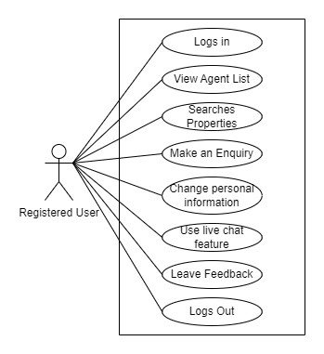

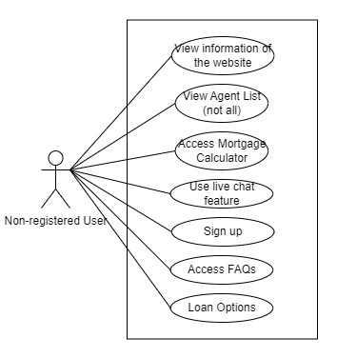

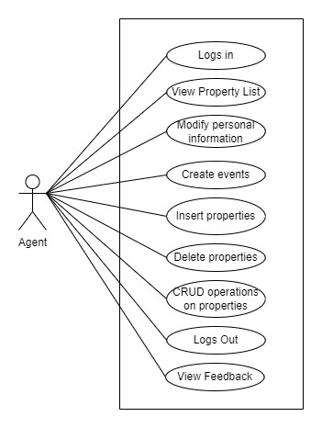

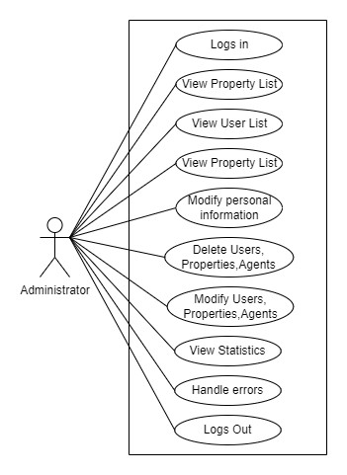

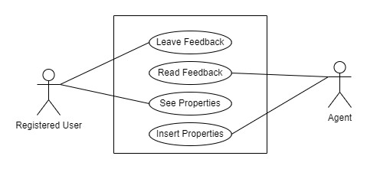

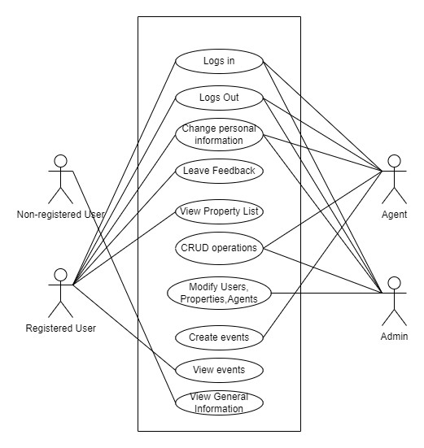’

**4.2.2 Activity Diagram**

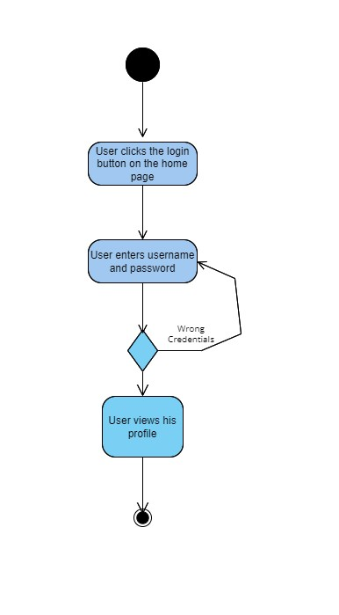

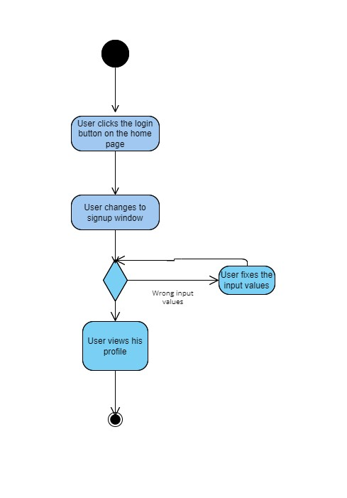

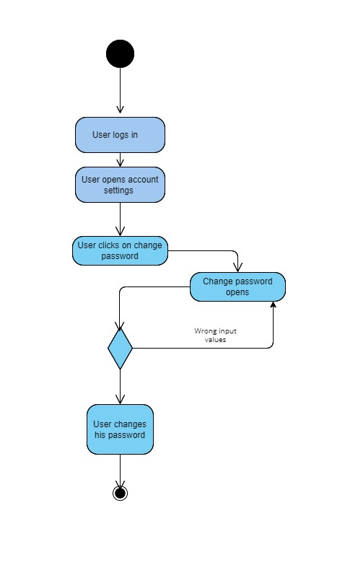

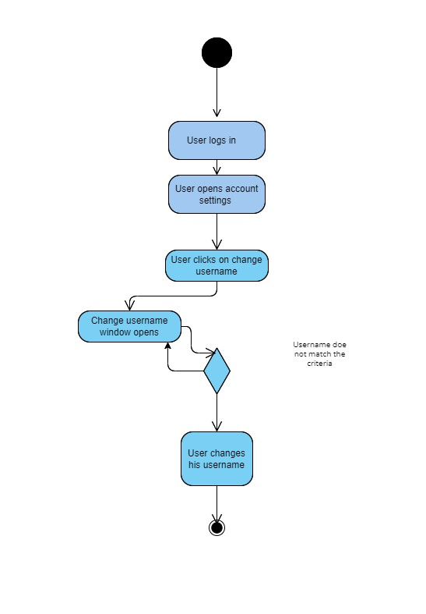

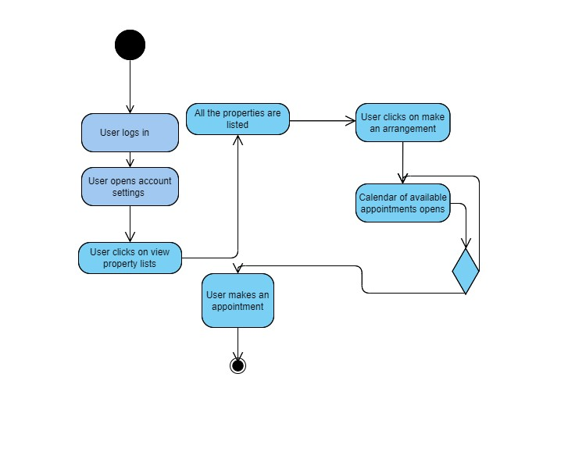

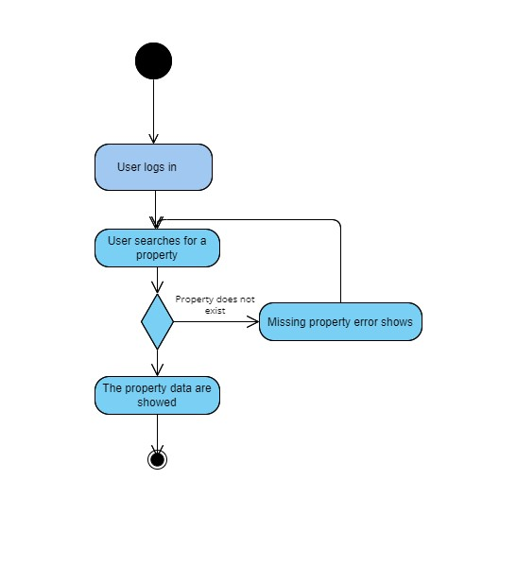

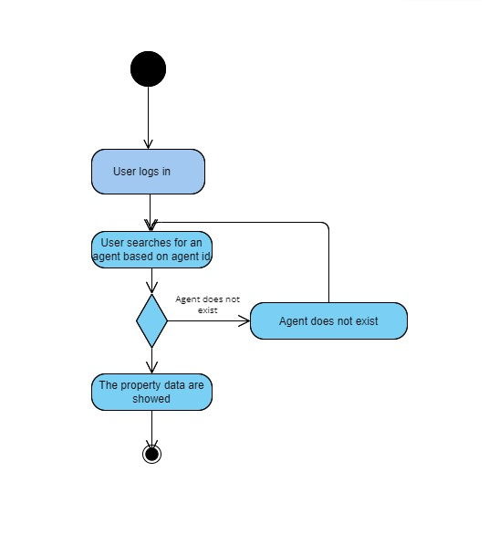

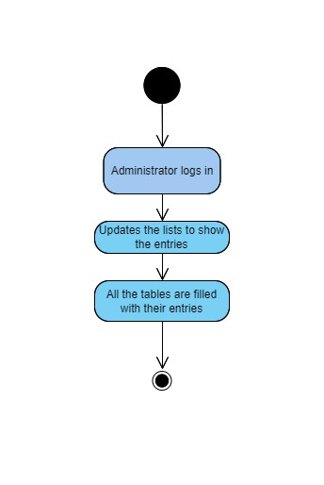

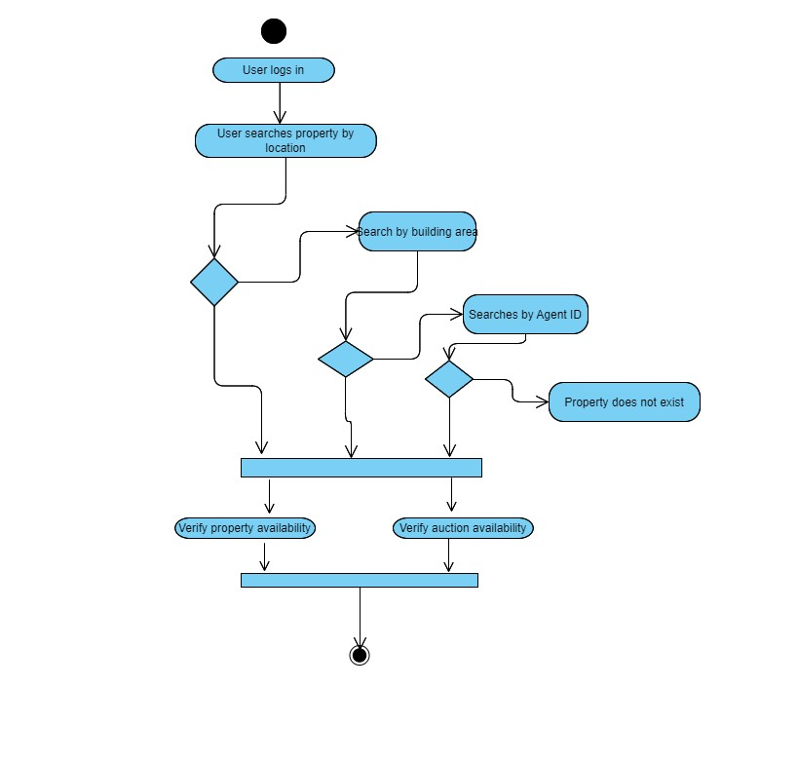

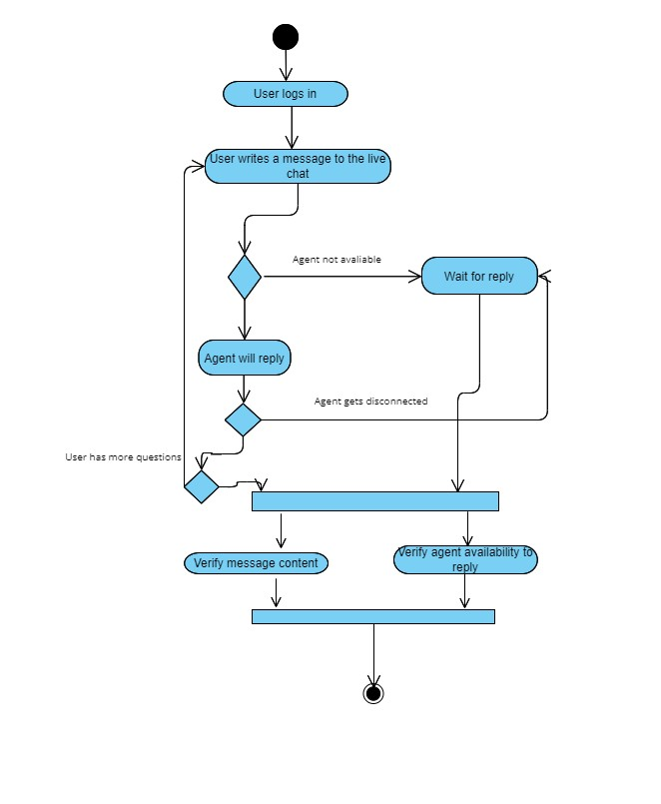

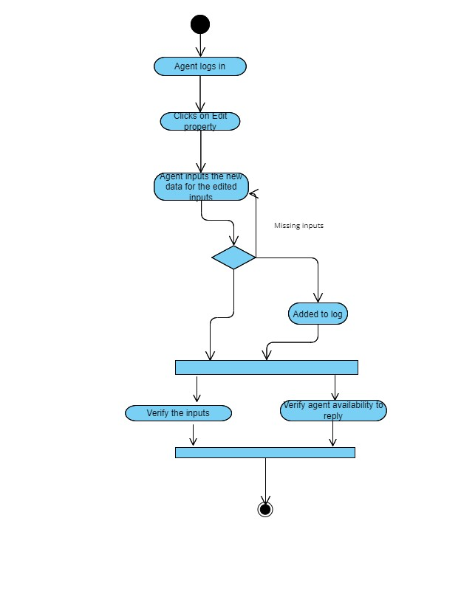

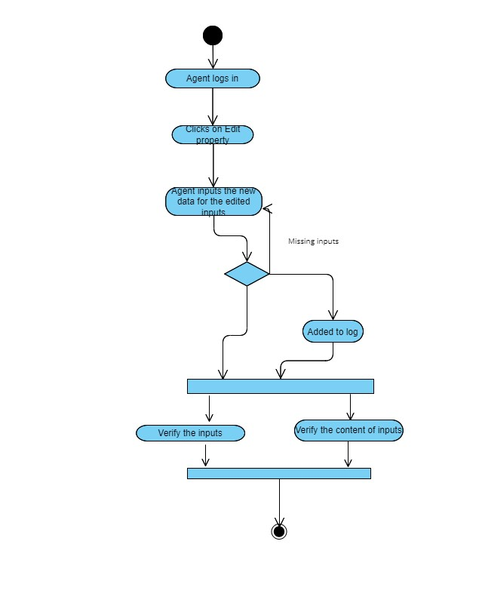

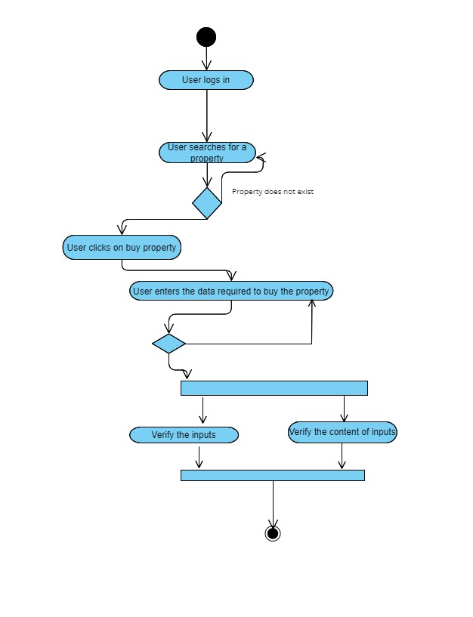

**4.2.3 State Diagrams**

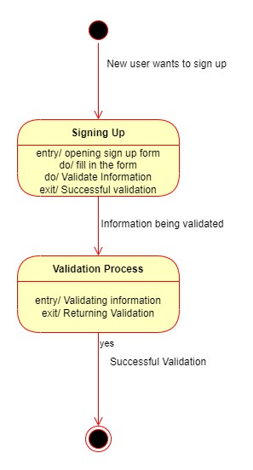

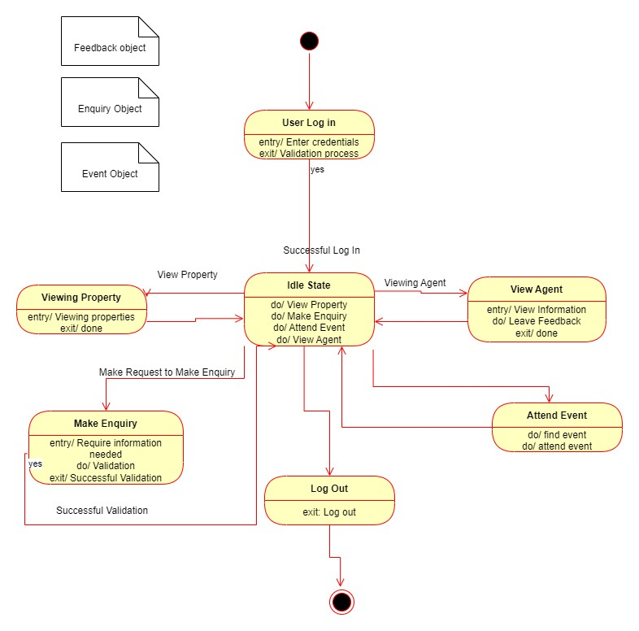

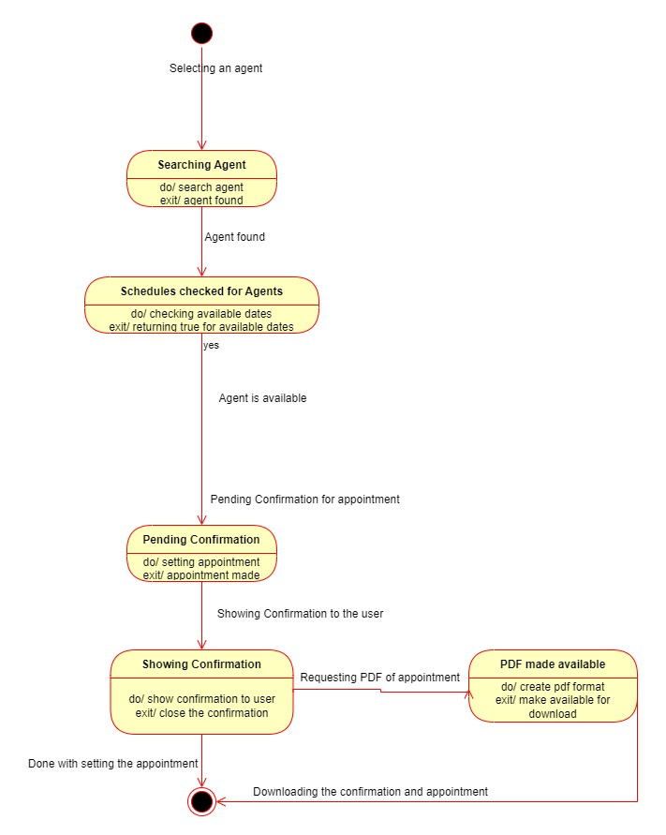

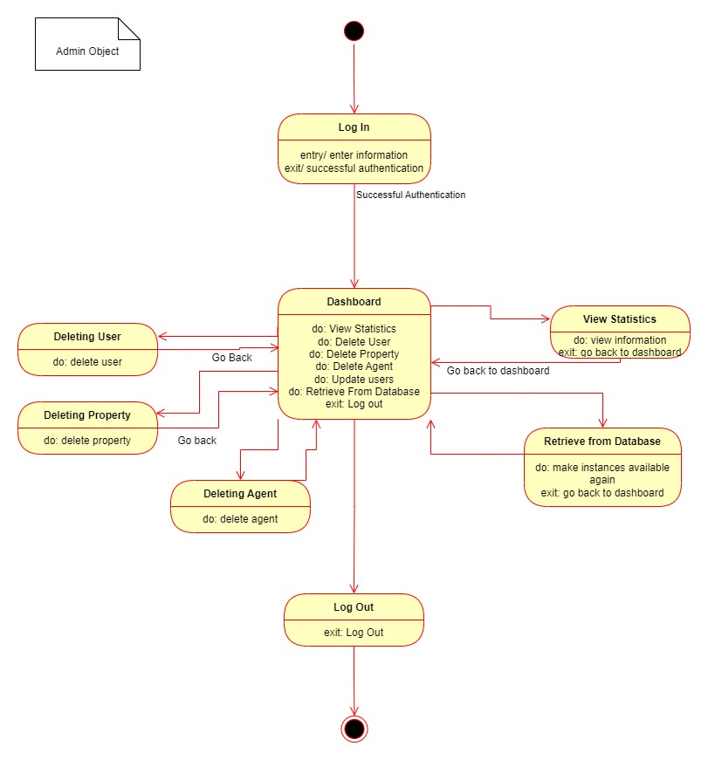

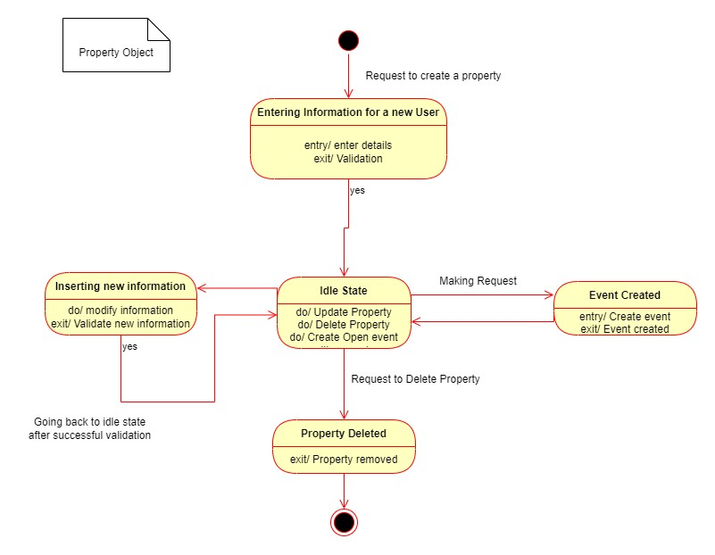

**4.2.4 Sequence Diagrams**

Title: User buying a property

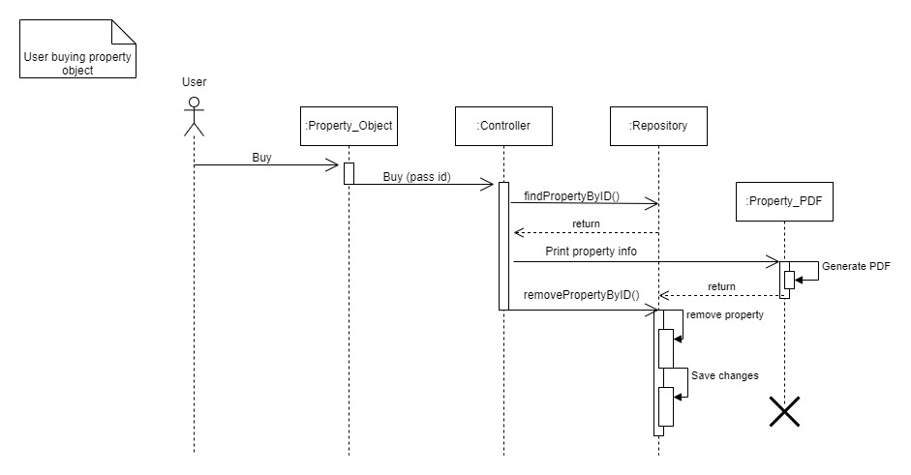

***Description:***

When a user wants to buy a property, he/she must click “Buy”. The Controller class then comes into action. We use the method findByID(). The controller should have access to the database, but instead, in order to make things more practical, a Repository is used. In backend, when dealing with CRUD operations from http requests, usually, instead of accessing the database directly, a repository is used. When the operation is finished, the repository has a method called saveChanges(), which is supposed to make the necessary changes to the database. At the end, a pdf report will be printed for the user who bought the property.

Title: User making an enquiry

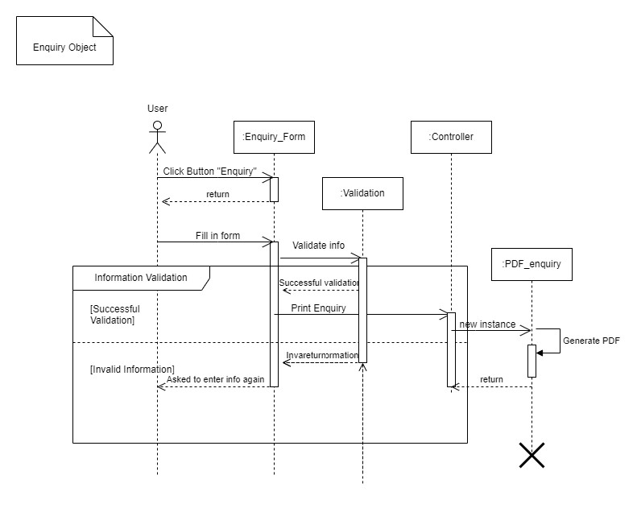

***Description:***

An enquiry is meant to be a verbal request from the user to the intended receiver (either the admin or agent). After filling in the information needed for the form to be complete, a validation process is needed. This is done for the sake of security reasons. If the information passes the validation process then it can go on further, passing the control to the controller which further prints a copy of the enquiry.

Title: Agent deleting property by ID

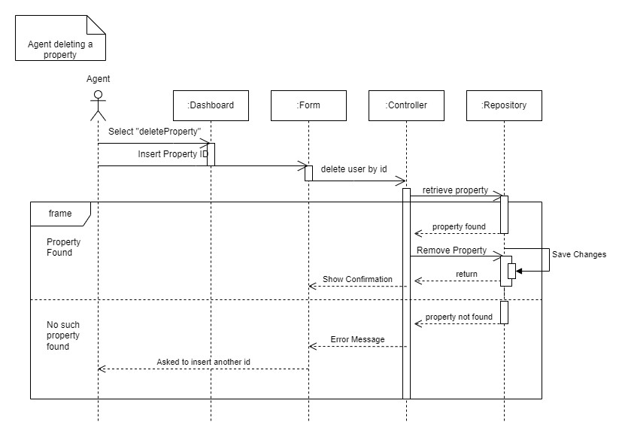

***Description:***

This sequence diagram represents the necessary steps followed to delete a property by specifying the id number from the agent. First the agent opens the dashboard and then he/she clicks on “Delete Property”. They then insert the ID of the property intended to be deleted. The frame is used to determine the two scenarios, one if the property with that ID is found and the other case when no such property is found. If the property is found, it is deleted by using the Repository as mentioned above and then the changes are saved in the database via data migration.

Title: User changing information

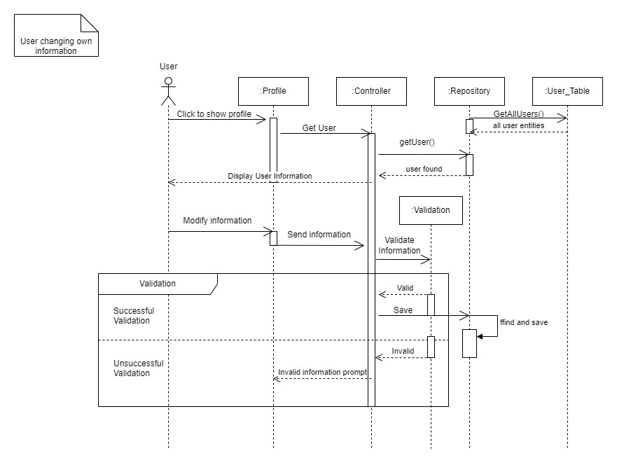

***Description:***

In this case the user intends to change personal information. When the form is filled, the new information has to undergo the validation process. If it doesn’t pass that process, then the user has to enter new information that complies with the regulations regarding security measures.

Title: Admin adding new property

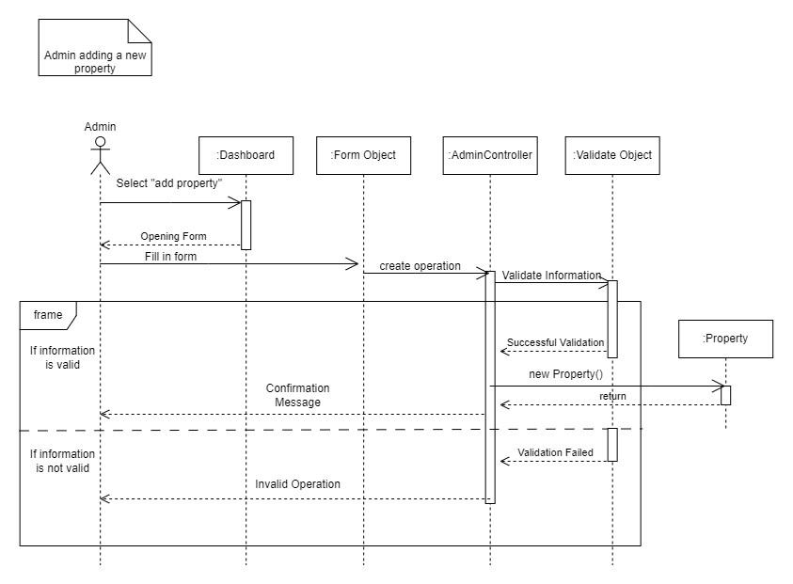

***Description:***

This sequence diagram represents the steps followed by the agent to add a new property. It is somehow the same process, filling in the form, going through the validation process. If the information doesn’t comply with what the programmer thought to be security-policy abiding information, then the agent will have to enter the information for that property again. If everything is okay, then the new property will be added to the repository and by using the migration process it will be saved to the database.

Title: Admin deleting user by id

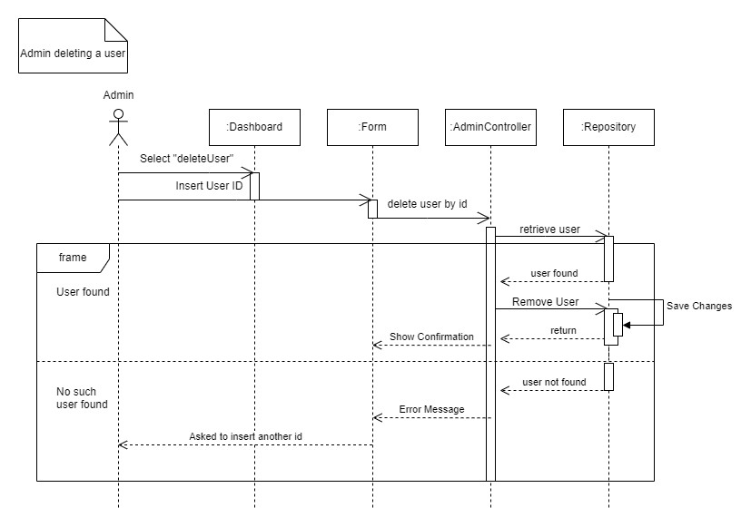

***Description:***

This is very similar to the sequence diagram for the process of deleting a property by id. In this diagram, the admin should insert the id of the user they want to delete. If it is found, the user will be deleted, otherwise the admin will have to enter another id that is actually valid.

Title: Agent adding new property

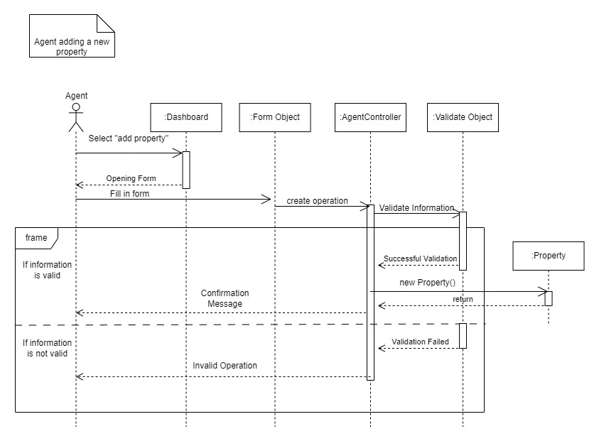

***Description:***

An agent adding a new property is quite similar to an admin adding a new property, both of them have access to such an operation. The information will be passed through the validation process and then the control will be passed to the Controller, which in turn will create a new entity of Property. Even though it is not shown in the diagram above (because it is intuitively understandable) the new property will be added to the Repository and then saved to the Database.

**4.2.5 Collaboration Diagrams**

